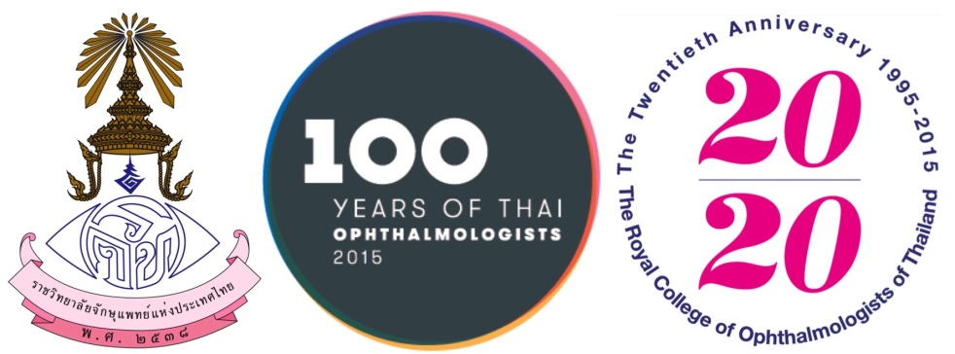

CERTIFICATE OF ATTENDANCE
This is to certify that
, MD
has Attended
The 35th RCOPT Meeting Reframing Inter-Specialty Consultation for the 21st Century
July 8-10, 2015
Centara Grand & Bangkok Convention Centre at CentralWorld, Bangkok, Thailand
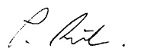

Paisan Ruamviboonsuk, MD Sorot Wutthipan, MD
President, the Royal College of Ophthalmologist of Thailand Scientific Committee Chair

