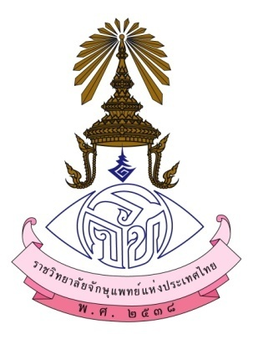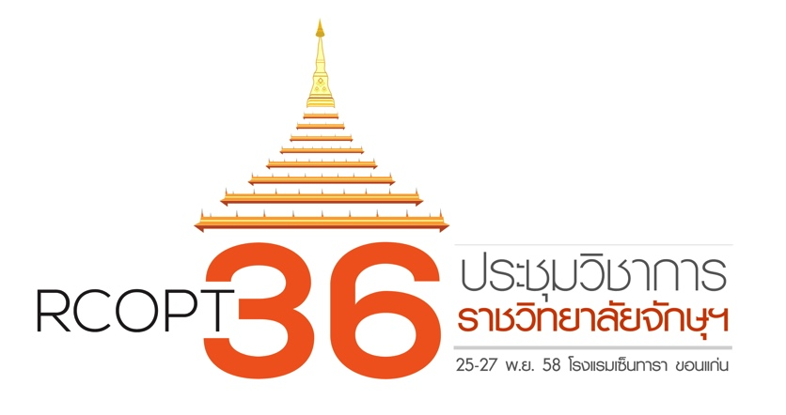

CERTIFICATE OF ATTENDANCE
This is to certify that
, MD
has Attended
The 36th RCOPT Meeting
November 25-27, 2015
Centara Hotel Khon Kaen, Thailand
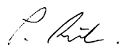

Paisan Ruamviboonsuk, MD Sorot Wutthipan, MD
President, the Royal College of Ophthalmologist of Thailand Scientific Committee Chair

